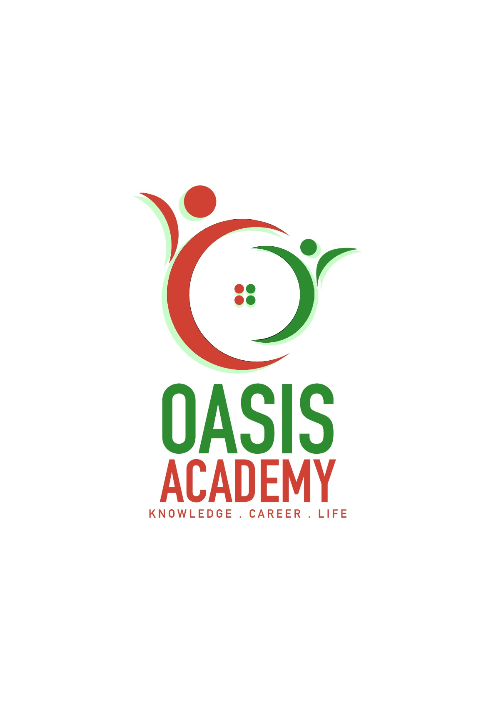

Name : KRISHNA BIRMA

Login ID : R03412920@oasis-portal.my

Course title : TOURISM AND HOSPITALITY

Subject Code : BHM04

Submitted date : 11.09.2017

**Table of Contents**

|  |  |  |
| --- | --- | --- |
| **No** | **Details** | **Page** |
| 1 | Executive Summary | 2 |
| 2 | Introduction | 3 |
| 3 | Assignment Question |  |
|  | Part 1 | 4 |
|  | Part 2 | 9 |
|  | Part 3 | 13 |
|  | Part 4 |  |
| 4 | Conclusion | 28 |
| 5 | References | 29 |
|  | Appendix |  |

**Executive Summary**

In this module, I introduce about the Tourism and Hospitality. In the first part of question I define the meaning of tourism and also the meaning of hospitality. In my understanding, tourism is a collection of activities, services and industries that delivers a travel experience, including transportation, accommodations, eating and drinking establishments, retail shops, entertainment business, activities facilities and other hospitality services provided for individual or groups travelling away from home.

Hospitality is a part of tourism. Hospitality means the main place tourist stay overnight. It must have guest and host. The community’s attitude which permeates every tourism location that makes the tourist feel welcome ad safe. It is the result of the interaction between the tourist and the local population.

In the second part, I briefed on different type of tourism. There are eight type of different tourist that people can used to travel. Next I have explained about types of hotels and types of catering offer according to the hotel levels. In catering section I’m giving importance to residential Catering Establishment. Overall in this module I have explained how the tourism and hospitality industry does.

**Introduction**

Since the beginning of time humans have traveled. Food, water safety or acquisitions of resources (trade) were the early travel motivations. But the idea of travel for the pleasure or exploration soon emerged.

The earliest travelers walked or rode domesticated animals. The invention of the wheel and the sail provided new modes of transportation. Each improvement in technology increased individual’s opportunities to travel. One of the earliest travel guides was written by Pausanias, a Greek, which was a 10 volume *Guide to Greece*, for Roman tourists in 170 A.D.

The world Tourism (WTO) claims that the tourism is currently the world’s largest industry with annual revenues of over $3 trillion dollars. Tourism provides six million jobs in USA, making it the country’s largest employer.

According to Larry Mogelonsky (2014) traveling is a perfect time for self- reflection and staying at a hotel is likewise great for contemplating aspects of our industry.

**Question 1 : Define the Tourism and Hospitality.**

**1.1 Definitions of Tourism**

According to Mathieson and wall (1982*)* tourism is the temporary movement of people to the destinations outsides their normal places of work and residence, the activities undertaken during their stay in those destinations and the facilities created to cater to their needs.

Macintosh and Goeldner (1986) tourism is the sum of the phenomena and relationships arising from the interaction of tourist, business suppliers, host governments and host communities in the process of attracting and hosting these tourist and other visitors.

Tourism is the activity or practice of touring for commercial purpose. Human doing activity travel to one place to another place and staying in places outside from their usual environment for more than one year or less than one year . It’s very important to every country. Because can generate income to that country and also consumption of goods and service by tourist.

**1.2 Hospitality**

Hospitality is the act of being friendly and welcoming of visitor and guests In this activity must have guest and host. Guest is customer or visitor and host is server. It’s the main place tourist can stay overnight. Normally the host will providing food, drinks, rooms, for people who are the guest or customer.

Graph 1: Dimension of Tourism

**Tourism and Hospitality**

* In tourism system there are three elements which are the people (tourist), the geographical elements and the tourism industry.
* The main activity in tourist is leisure (holiday), business (MICC), pilgrimage (religion), Recreational (sport), Adventure, health, education and VFR.
* Tourism and Hospitality consist of lodging accommodation, staying, travel and tourism recreation, amusements, attraction, resort, restaurants and food beverage service.
* It’s a largest employment rate in a country.
* The tourism product consists of the 6A’s :

1. ***Access (transport)***

* Tourists are using transportation to travel to one place to another place.
* Types of transport are land, sea, and air.
* The mode of transport describes the type of transport used.

There are basically five different options. For example rail (tourist use MRT/KTM or train travel), road (tourist use car, motorbike, travel vans and buses to go one place to another place), travel also can use water transportation like ship and cruise. Tourist also can use air transportation just like flight, air balloon and aircraft. Finally tourist also can use pipeline to travel just like cabs and taxi.

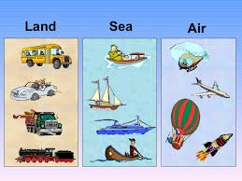

1. ***Accommodation***

* The place tourism can stay overnight.
* For example hotel, motels, florets, inns, resort, serviced apartment, bed and breakfast.

[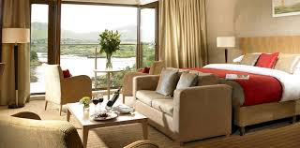](https://www.google.com.sg/imgres?imgurl=http://www.skiesconsultancyservices.com/accommodation.jpg&imgrefurl=http://www.skiesconsultancyservices.com/accommodation&docid=5vrc_evm6Vc5tM&tbnid=Mb8L5IxkOu-N0M:&vet=10ahUKEwiOyc2tzvjVAhXBvo8KHRxoCpwQMwjrAihcMFw..i&w=760&h=375&bih=643&biw=1366&q=accommodation&ved=0ahUKEwiOyc2tzvjVAhXBvo8KHRxoCpwQMwjrAihcMFw&iact=mrc&uact=8)

1. ***Attractions***

* For attractive tourist to come and visit that place. It can be natural or man-made just like Marina Bay, Sentosa Island, Universal Studio in Singapore and Langkawi in Malaysia.

[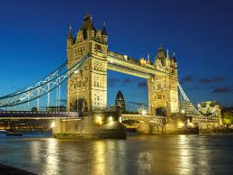](http://www.google.com.sg/url?sa=i&rct=j&q=&esrc=s&source=images&cd=&cad=rja&uact=8&ved=0ahUKEwi5k9Cy0PjVAhUL6Y8KHTCABl8QjRwIBw&url=http://www.readersdigest.ca/travel/world/50-must-see-london-attractions/&psig=AFQjCNFg2P4CYwMi9yW2YIJToyWRNuRJbw&ust=1503964837581450)

1. ***Activities***

* Activities like festival and events that tourist can take part and see the deferent culture activities as Chinese new year , Deepavali ,Christmas and national day.

[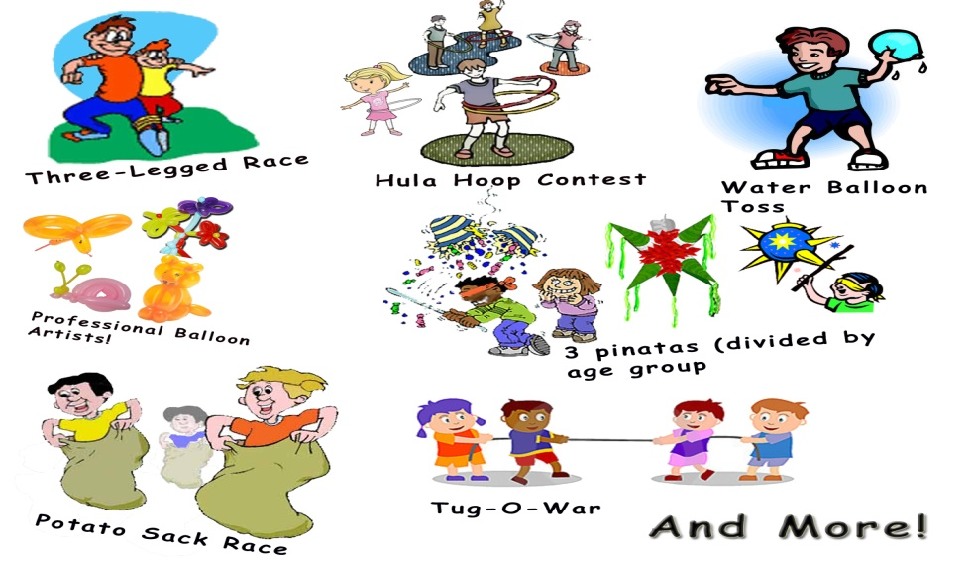](https://www.google.com.sg/url?sa=i&rct=j&q=&esrc=s&source=images&cd=&cad=rja&uact=8&ved=0ahUKEwjvluD10PjVAhWMpo8KHW_DBtcQjRwIBw&url=https://www.pinterest.com/pin/196258496234278504/&psig=AFQjCNECyG_mqlanDW__XW5M9JgAwM0EdQ&ust=1503965077424225)

1. ***Amenities***

* Its essential facilities that tourist can used just like spa, swimming pools, Jacuzzi and BBQ.

[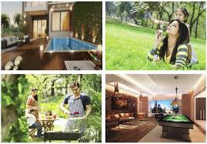](http://www.google.com.sg/url?sa=i&rct=j&q=&esrc=s&source=images&cd=&cad=rja&uact=8&ved=0ahUKEwj_wYC50fjVAhVCqo8KHS3yD4EQjRwIBw&url=http://www.purvacoronationsquare.contact-us-now.com/amenities.html&psig=AFQjCNF_2m4mXR3Nj-K_FCBl8wu_zcuNgg&ust=1503965215108449)

1. ***Ancillary services***

* The extra services like help arranging transport services to tourist, booking room or hotels and tour guides for tourist who need help.

[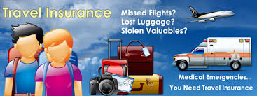](https://www.google.com.sg/imgres?imgurl=http://investigatingthetravelandtourism.weebly.com/uploads/1/3/6/9/13696986/1915364_orig.jpg&imgrefurl=http://investigatingthetravelandtourism.weebly.com/ancillary-services.html&docid=UgObW60hNr5TxM&tbnid=kwmrNUOm6zKRqM:&vet=10ahUKEwjplcPk0fjVAhUJOY8KHbU0CIQQMwhvKEIwQg..i&w=650&h=244&bih=643&biw=1366&q=6.%09Ancillary%20services&ved=0ahUKEwjplcPk0fjVAhUJOY8KHbU0CIQQMwhvKEIwQg&iact=mrc&uact=8)

**1.2 Definition of hospitality**

My understanding about Hospitality industry it is a Felds of services industry like lodging, event, planning, and Team Park, transportation and cruise line. Hospitality units are restaurants and bar, hotels, night clubs and pub.

The dictionary defines hospitality as ‘the friendly and generous reception and entertainment of guests’.

Hospitality means catering to guests needs. Catering to guests needs means welcoming. Welcoming means being friendly and generous. (Larry Mogelonsky, 2014)

Hospitality also can be defined as the business of helping people to feel welcome and relaxed and to enjoy themselves (Discover Hospitality, 2015). It’s a combination of accommodation, food and beverage groupings.

Hospitality is the act of being friendly and welcoming of visitors and guest. It must have guest and host. Guest is customer or visitor and host is server. It’s the main place tourist can stay overnight. Normally the host will provide food, drinks, and rooms, for people who are the guests or customers.

The success of the service
- Focus on the guest
- Understand the role of the guest-contact
employee
- Weave a service cult...

Scope of the Hospitality- Tourism Industry.

**Question 2 : Brief on different type of Tourism categories**

There are **eight** type of different in Tourism categories.

1. **Sports tourism**

It’s a type of activity holiday. The purpose is for exercise and keeps physically fit. Same time they enjoy with natural surroundings, fresh air and clean water .Its combine of action and relaxation. For example hiking, cycling, boating, rafting and other kind of sporting tour.

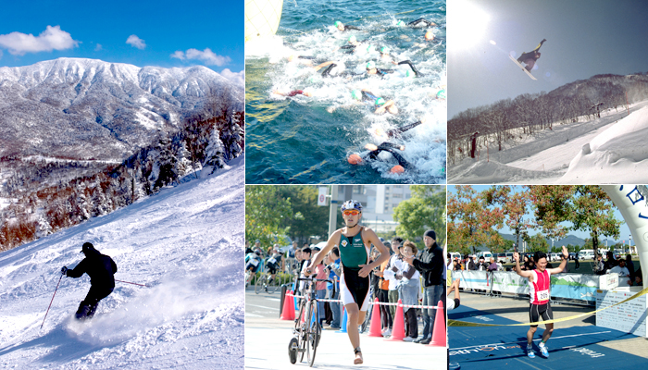

1. **Leisure Tourism**

It’s a holiday tourism or pleasure tourism. They travel for gain experience in new places, new culture and change climate. Normally they travel for sun; sea and sand. They want to go sunbathing, swimming and diving.

[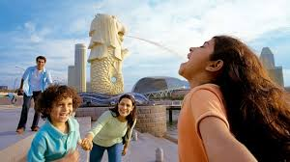](https://www.google.com.sg/imgres?imgurl=http://www.visitsingapore.com/en_au/see-do-singapore/recreation-leisure/viewpoints/merlion-park/_jcr_content.renderimage.carousel.rect.740.416.jpg&imgrefurl=http://www.visitsingapore.com/en_au/see-do-singapore/recreation-leisure.html&docid=kKhcPDsG-qwMPM&tbnid=TEPeFA39rSQzjM:&vet=10ahUKEwiwg-ew1fjVAhWHL48KHQfpBesQMwiKASg8MDw..i&w=740&h=416&bih=643&biw=1366&q=Leisure%20Tourism&ved=0ahUKEwiwg-ew1fjVAhWHL48KHQfpBesQMwiKASg8MDw&iact=mrc&uact=8)

1. **Business tourism**

People travel for business purpose. Tourist travel in different mission. They travel to expend their business or mainland current business level. They travel for taking part in a conference or a seminar. They also travel for meeting clients or selling products

[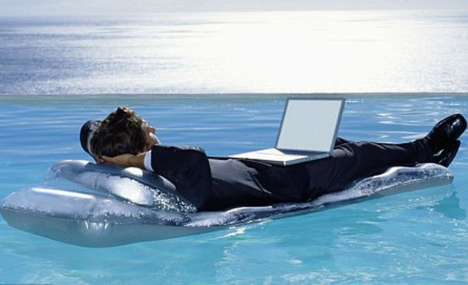](http://list25.com/25-bizarre-types-of-tourism-you-might-want-to-try/).

1. **Culture tourism**

One type of culture that visiting any other culture then their own like traveling of foreign country. The traveler attractive with other regions culture, for example lean lifestyle of people in geographical areas, history of those people, art, architecture and other element that they think can help shape their life style.

[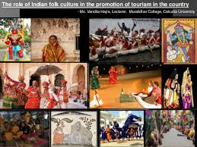](https://www.google.com.sg/imgres?imgurl=https://image.slidesharecdn.com/theroleofindianfolkcultureinthepromotionoftourisminthecountry-150222132656-conversion-gate01/95/role-of-indian-folk-culture-in-promotion-of-tourism-in-the-country-paripex-indian-journal-of-research-vol-4-issue-2-february-2015-1-638.jpg?cb=1424612335&imgrefurl=https://www.slideshare.net/VanditaHajra/the-role-of-indian-folk-culture-in-the-promotion-of-tourism-in-the-country&docid=k6aljVUiJrpEsM&tbnid=TRwndwR3YCEPPM:&vet=10ahUKEwjexe2J1vjVAhUSTI8KHYPVDOkQMwhJKBwwHA..i&w=638&h=479&bih=643&biw=1366&q=%094.%20Culture%20tourism&ved=0ahUKEwjexe2J1vjVAhUSTI8KHYPVDOkQMwhJKBwwHA&iact=mrc&uact=8)

1. **Religious tourism**

It’s also called as faith tourism. People travel in group or individually for pilgrimage or spiritual tourism. For example annual Hajj pilgrimage in Mecca, Saudi Arabia, Holy cities in Mecca, Medina, and Church of the Nativity in Bethlehem and Basilica of our Guadalupe in Mexico City

[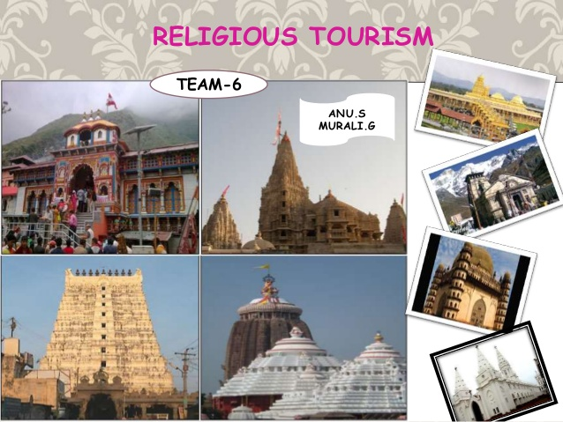](https://www.google.com.sg/url?sa=i&rct=j&q=&esrc=s&source=images&cd=&cad=rja&uact=8&ved=0ahUKEwiPm4jF0_jVAhXEqY8KHaryBb0QjRwIBw&url=https://www.slideshare.net/Anusachi/religious-tourism-in-india-47712448&psig=AFQjCNFtxlBaw6oWo9bi3eJtsO-2TjepLQ&ust=1503965761014866)

1. **Family tourism**

Family tourism for reunite the family to spend time together. They go in a group, friend, family and relatives. This can increase their family relations to closer.

[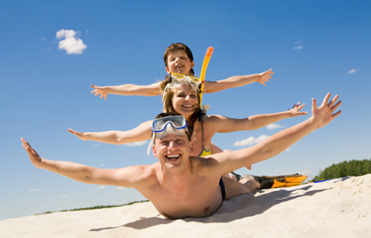](http://www.google.com.sg/url?sa=i&rct=j&q=&esrc=s&source=images&cd=&cad=rja&uact=8&ved=0ahUKEwiflYuO1PjVAhVFK48KHQGNCvoQjRwIBw&url=http://www.andalucia.com/tourism/family.htm&psig=AFQjCNEAW2HbHAhtbQ5BpuegANJfPcCedQ&ust=1503965947675022)

1. **Health tourism**

Its focus on medical treatment. They travel to another country to receiving medical or wellness services. Its divided into two categories:

* ***Health tourism*** is tourist travel for receive treatment.
* ***Wellness tourism*** is tourist travel to maintain their physical and psychological health by receiving certain services

[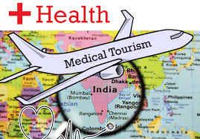](https://www.google.com.sg/imgres?imgurl=http://www.indianyouth.net/wp-content/uploads/2015/12/Medical-tourism-in-India.png&imgrefurl=http://www.indianyouth.net/medical-tourism-in-india/&docid=lSJIoUeMvnoldM&tbnid=1M3x2XdhpQP2dM:&vet=10ahUKEwiA3M211PjVAhUcT48KHWYAD1k4ZBAzCBUoEzAT..i&w=500&h=348&bih=643&biw=1366&q=Health%20tourism&ved=0ahUKEwiA3M211PjVAhUcT48KHWYAD1k4ZBAzCBUoEzAT&iact=mrc&uact=8)

**8. Educational tourism**

Tourist travel to grow their knowledge, experience and skills. There are four type of travelling:

1. youth travelling > school excursions, youth exchanges such as visit historical, culture and educational.
2. Tourism education > Full time study program.

> participate in international exchange programs. Complete students degrees in different country.

1. Workshop travel > like seminar and Edu tourism .Symposium distinction learns.
2. Language school > learns foreign language.

[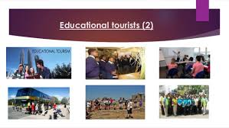](https://www.google.com.sg/imgres?imgurl=https://image.slidesharecdn.com/tourismdevelopmentgrade10-140308050545-phpapp01/95/tourism-development-grade-10-4-638.jpg?cb=1394255184&imgrefurl=https://www.slideshare.net/ntandojessica/tourism-development-grade-10&docid=hI4zu6ZXlWKFAM&tbnid=JQW81yX44UpcYM:&vet=10ahUKEwj746KB1_jVAhWIL48KHU4WDTQQMwgzKBAwEA..i&w=638&h=359&bih=643&biw=1366&q=4.%20.%20Educational%20tourism&ved=0ahUKEwj746KB1_jVAhWIL48KHU4WDTQQMwgzKBAwEA&iact=mrc&uact=8)

**Question 3 : Describe the lodging accommodation and type of hotel accommodation.**

A hotel is an establishment that provided paid lodging on a short term basis. It provides basis accommodation in time past, consisting only of a room with a bed, a cupboard, a small table and a washstand.

**3.1 Types of hotels**

The hotel industry is classified on the following basis.

1. On the basis of location.
2. On the basis of target market
3. On the basis of size of property
4. On the basis of theme

**3.1.1 Based on location**

1. **Downtown hotels**

* Located in the heart of the city
* Near shopping area, theaters and etc.
* High rates

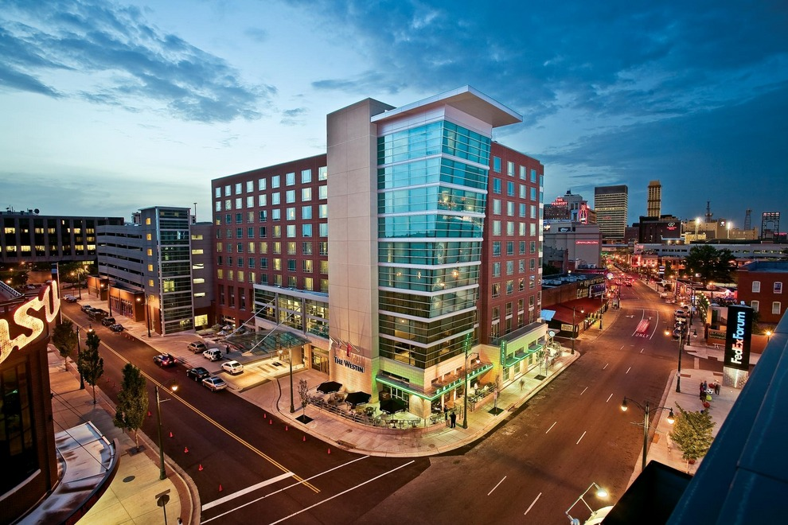

1. **Suburban hotels**

* Located in the suburbs
* Have quieter surrounding
* Rates are moderate
* Ideals for budget traveler

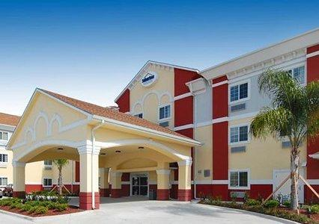

1. **Motels**

* Derived from the motor hotels
* Located on highways
* Provide ample parking space
* Usually located near fuel pumps

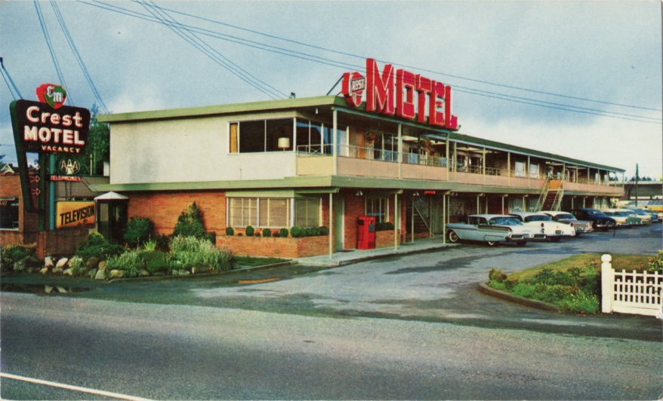

1. **Airport hotels**

* Set up near airports
* Cater transit guest

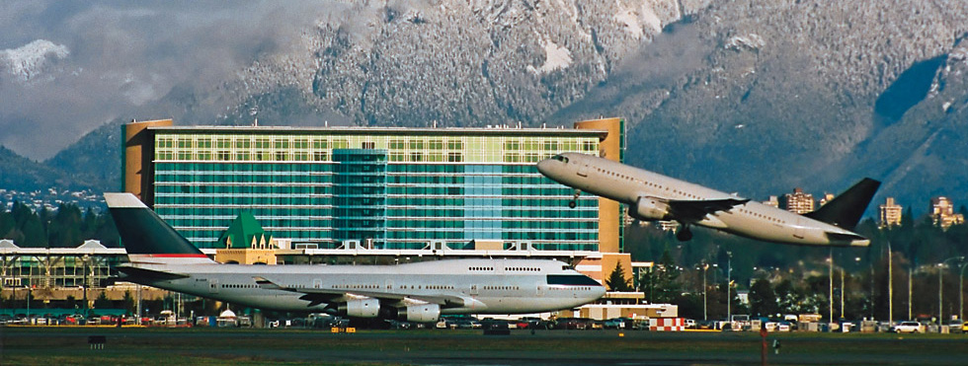

1. **Resort hotels**

* Are located near a sea shore or hill stations
* Cater people who wants to relax and enjoy
* Maybe called health resort, hill resort or beach resort.
* Are generally seasonal in nature

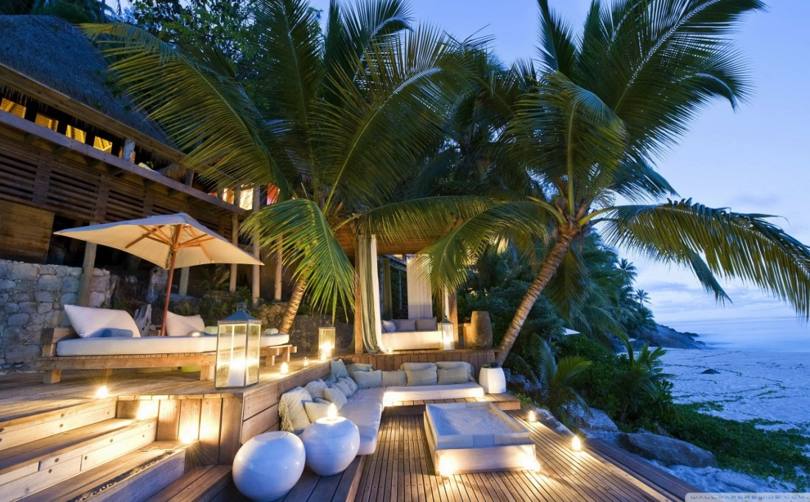

1. **Forest hotels**

* Located within a forest range
* Cater tourist visiting the forest area

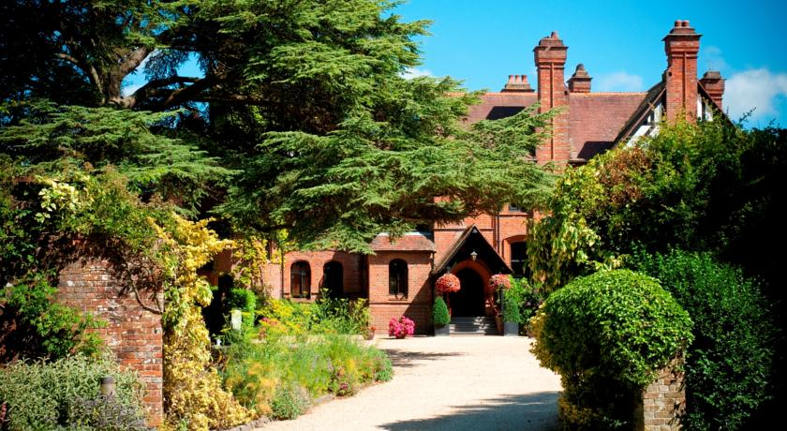

1. **Floatels**

* Establish on luxury liner or ships
* Cruise ship

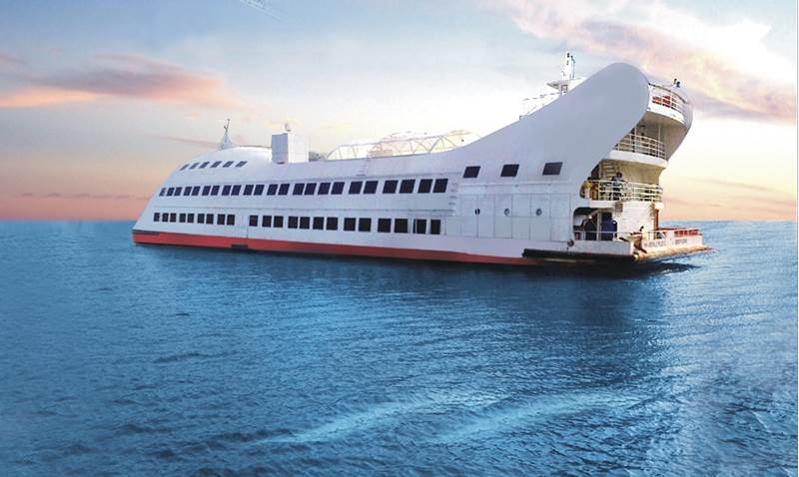

1. **Boatels**

* House boat
* Example: Shikara of Kashmir

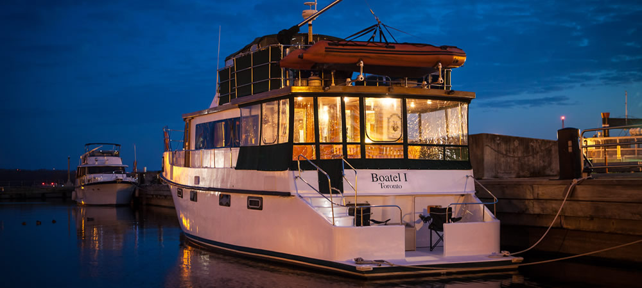

1. **Raotels**

* Hotels on wheels
* Palace of wheels
* Used by a small groups of traveler

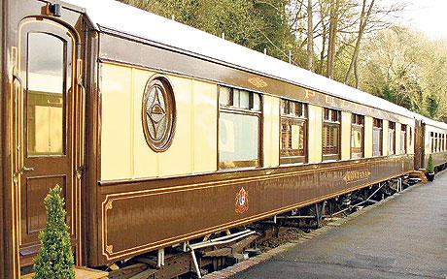

**3.1.2 Based on a target market**

**1. Commercial hotels**

* Typically designed on European plan
* Cater business men
* Situated in busy commercial area
* Example : Holiday inn, London

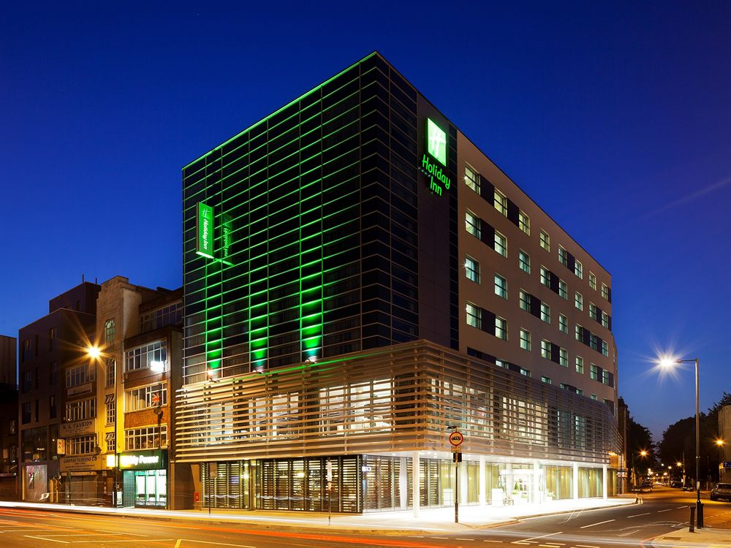

**2. Convention hotels**

* Have a large convention complex
* Cater people attending convention, conference.

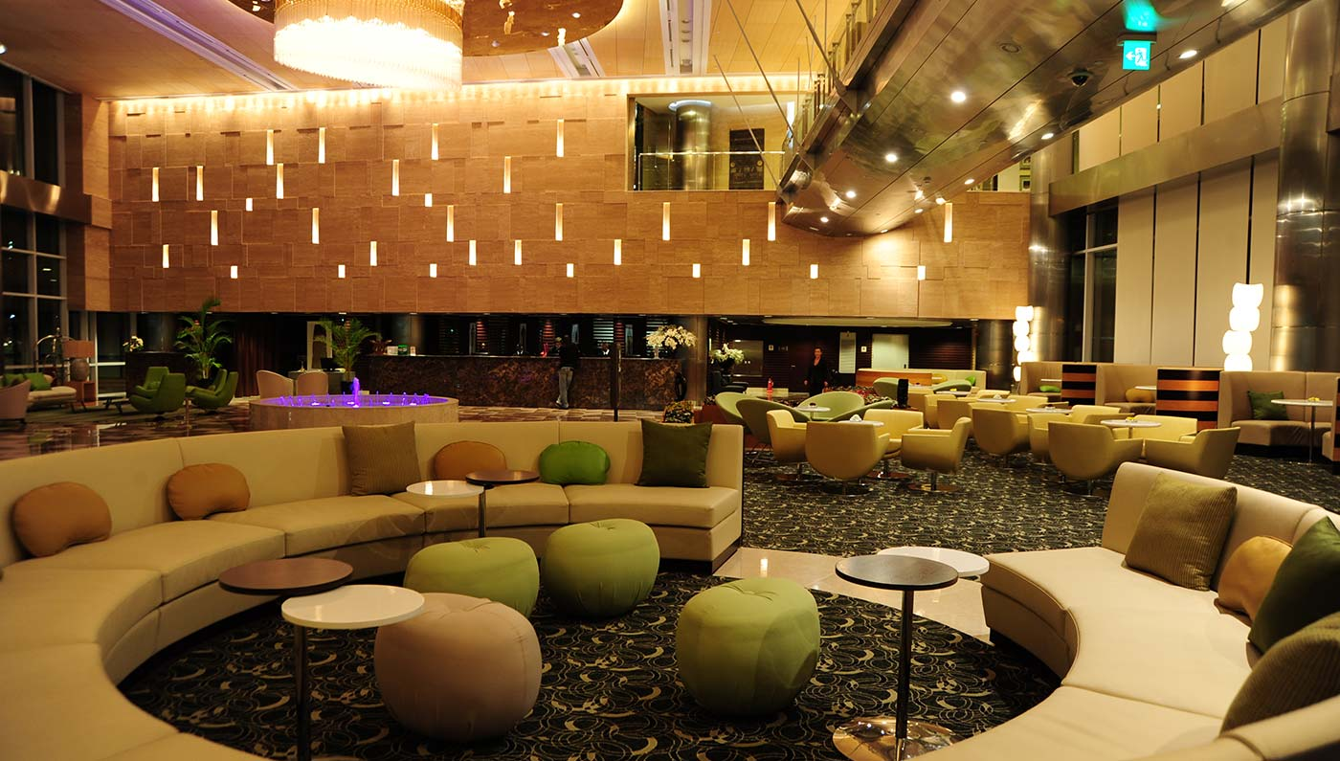

**3. Suits hotels**

* Offer room with compact kitchen
* Cater o people relocating act as a home away from home
* Suitable for executives during a longer business stay.

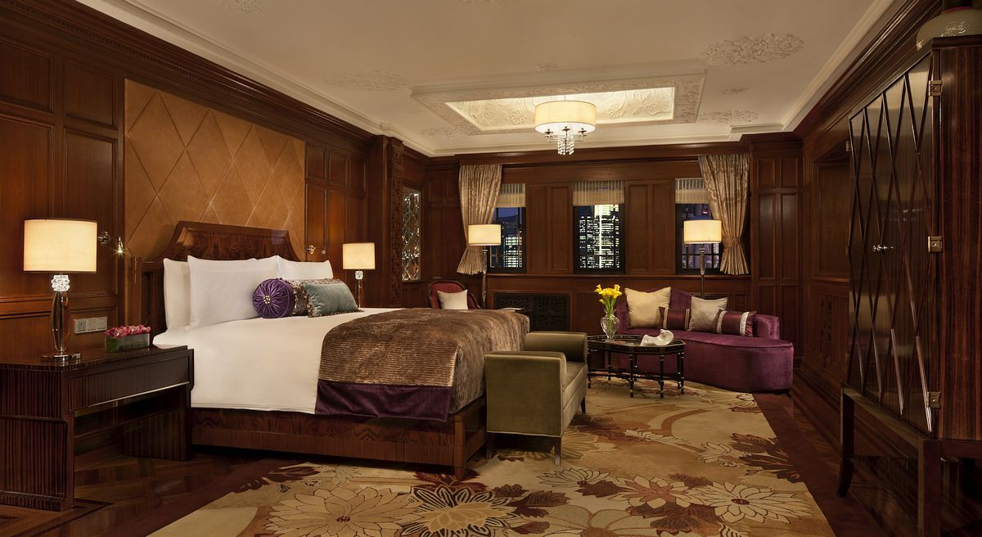

**4.B&B hotels (Bed & Breakfast)**

* A European concept
* Range from house with a few room with overnight facilities
* Owner lives on the premises and serves breakfast to guest.

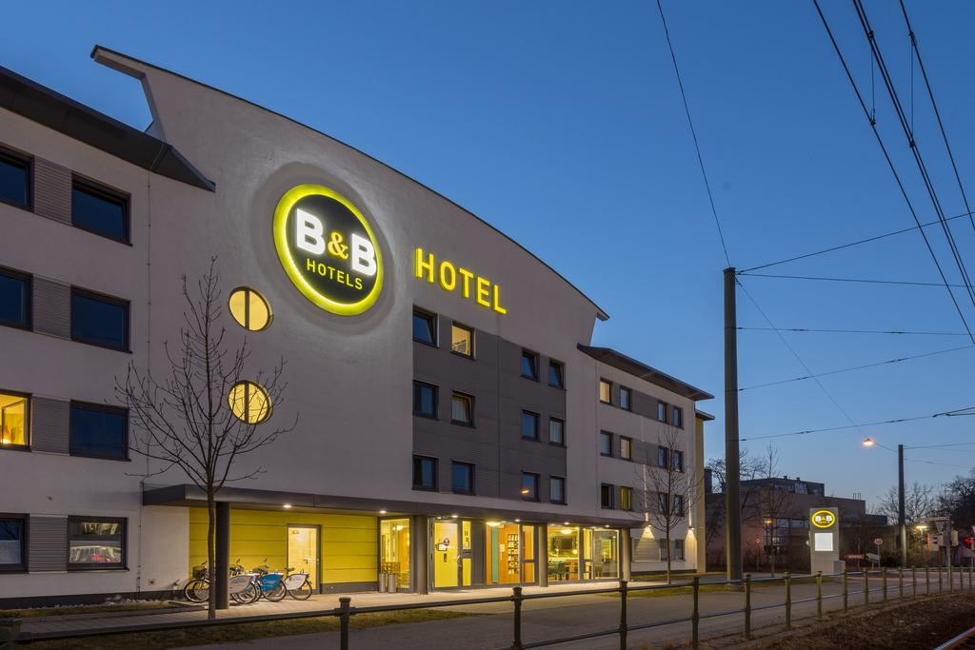

**5. Extended stay hotels**

* Similar to suit hotels
* Offer kitchen amenities in the room
* For travelers who intend to stay 5 days or longer
* Require reduced hotel services

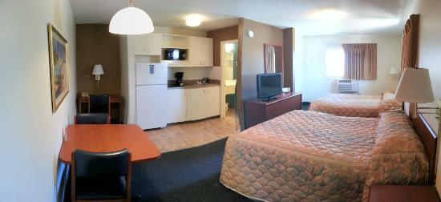

**6. Casino hotels**

* Hotels with pronominally gambling facilities
* Rooms and F&B may be quite luxuries

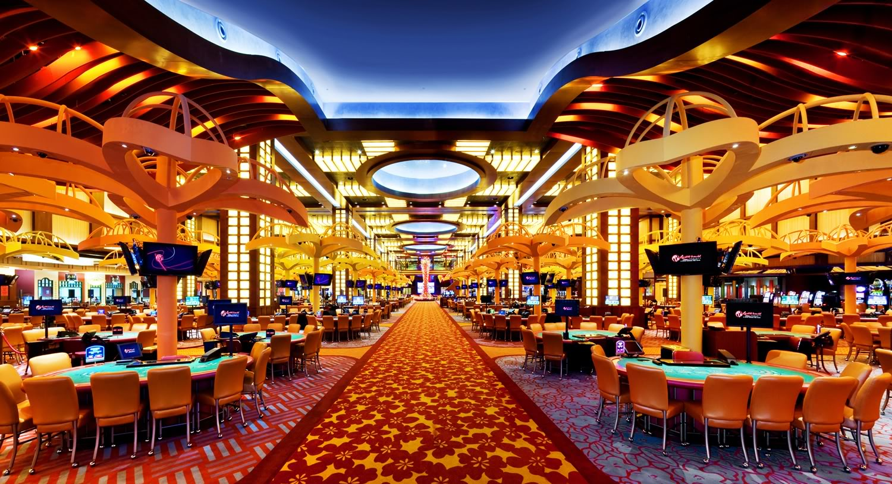

**7. Timeshares**

* Referred to as vacation interval hotels
* Individuals purchase the ownership of accommodation for a specific period
* Have multiple owners

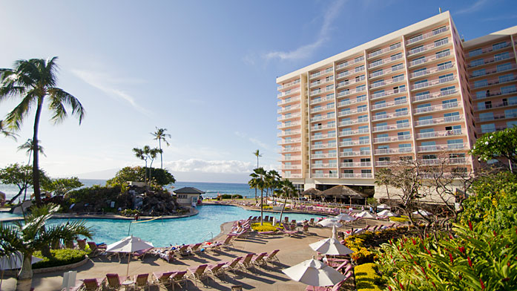

**8. Condominiums**

* Similar to timeshares
* Differences lies in the type of ownership
* Have single owner for a limited amount of time
* Owner informs the management that when he or she wants to occupy the units.

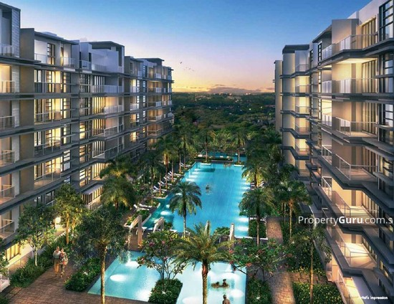

**9. Service Apartments**

* Corporate lodgings
* Designed for guests wishing to stay longer periods of time (6 month or longer)
* Business executives
* Provides furnished apartments

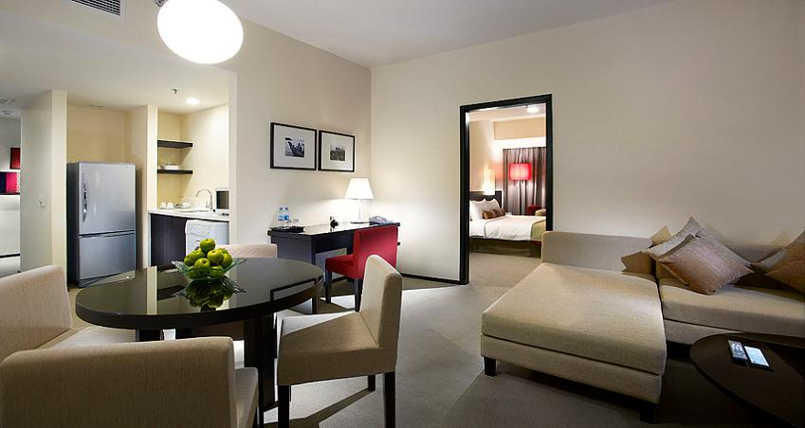

**3.1.3 Based on size of property**

* Small hotels : 25 rooms and less
* Medium size hotels : 25 – 100 rooms
* Large hotels : 101 – 300 rooms
* Very large hotels : more than 300 rooms
* Mega hotels : more than 1000 rooms
* Chain hotels: groups that have hotels in number of location.

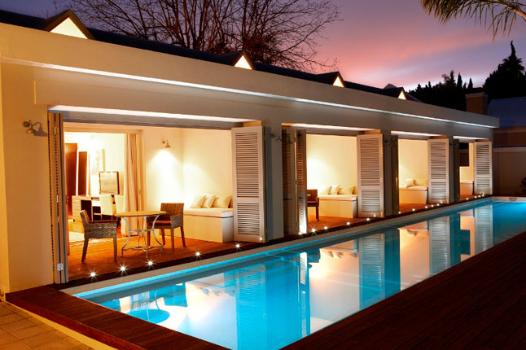

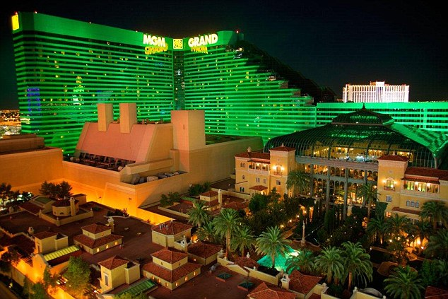

* + 1. **Based on theme**

**1. Ecotels**

* Environment friendly hotels

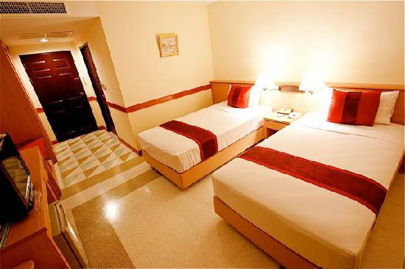

**2. Boutique hotels**

* Provides exceptional accommodation
* Furnished in a themed and stylish manner
* Cater to corporate traveler who place high importance privacy, luxury and service delivery.

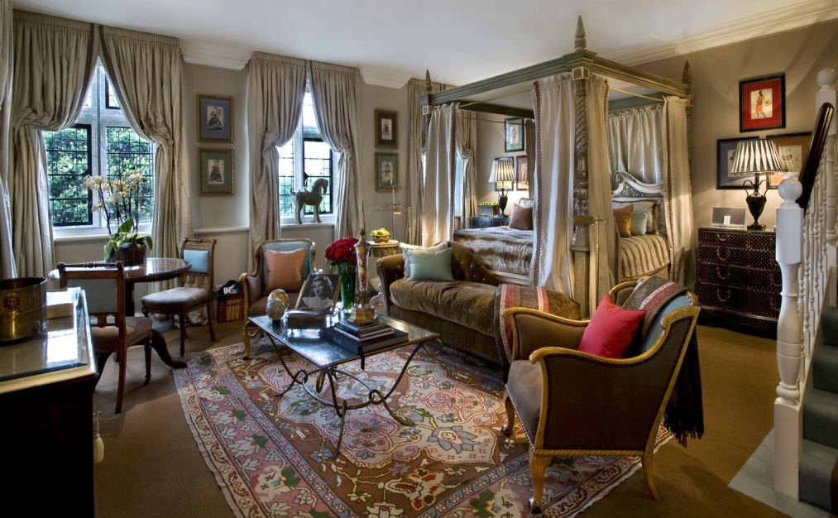

**3. Herritage hotels**

* Among tourisms recent gains in India
* Serves in traditional cuisine
* Allows a glimpse inti the heritage of the regions
* Cover hotels in residences, have lies, hunting lodges, castles, forts and palaces.
* Includes: heritage, heritage classic and heritage grand**.**

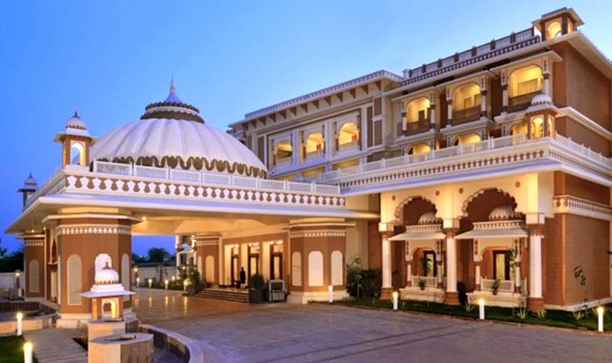

**4.SPA**

* Any place with a medicinal or mineral spring
* Tub for relaxation
* Resort hotels providing therapeutic baths and massages along with features of luxury hotels
* Medical spa operates under onsite supervision of licensed health care professional

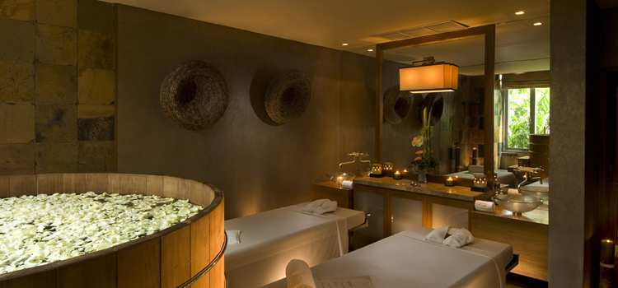

**4. Explain the significant of Entertainment in this industry.**

Entertainment sector is doing activity to take away peoples stress and give them relaxation. In hospitality industry entertainment is very important sector. Tourist likes to visit places like movie theaters, Water Park, carnival, cruise, night club and so on. Entertainment gives attention and interest of an audience. Tourist also can learn different kind of performance exist in all cultures.

* 1. **Type of entertainment**

**Marinas** – It’s a waterside facility like docks, moorings, for small boats. Tourist can bring their family to yacht for vacation.

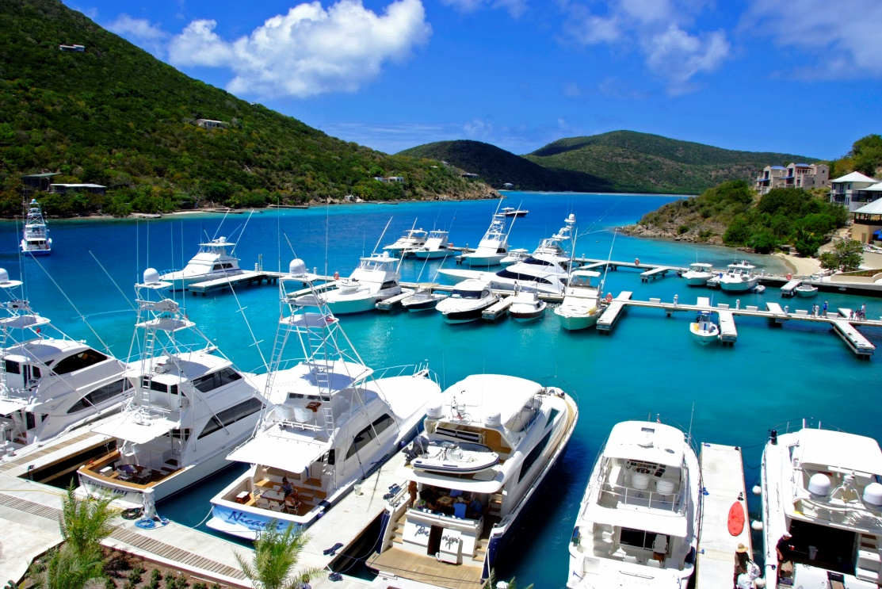

**Sports and gaming** – It’s a physical activity carried out under an agreed set of rules.



**Cruise** – cruise used for pleasure voyages. People most of time spend in middle of sea. The ship makes two to three night rounds trips. Its also call as water tourist.

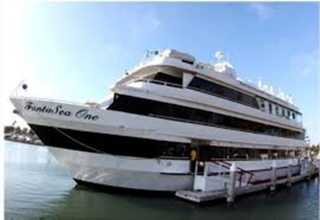

**Night club** – Night club means club open evening until early morning. They are having facility like bar and disco and other entertainment.

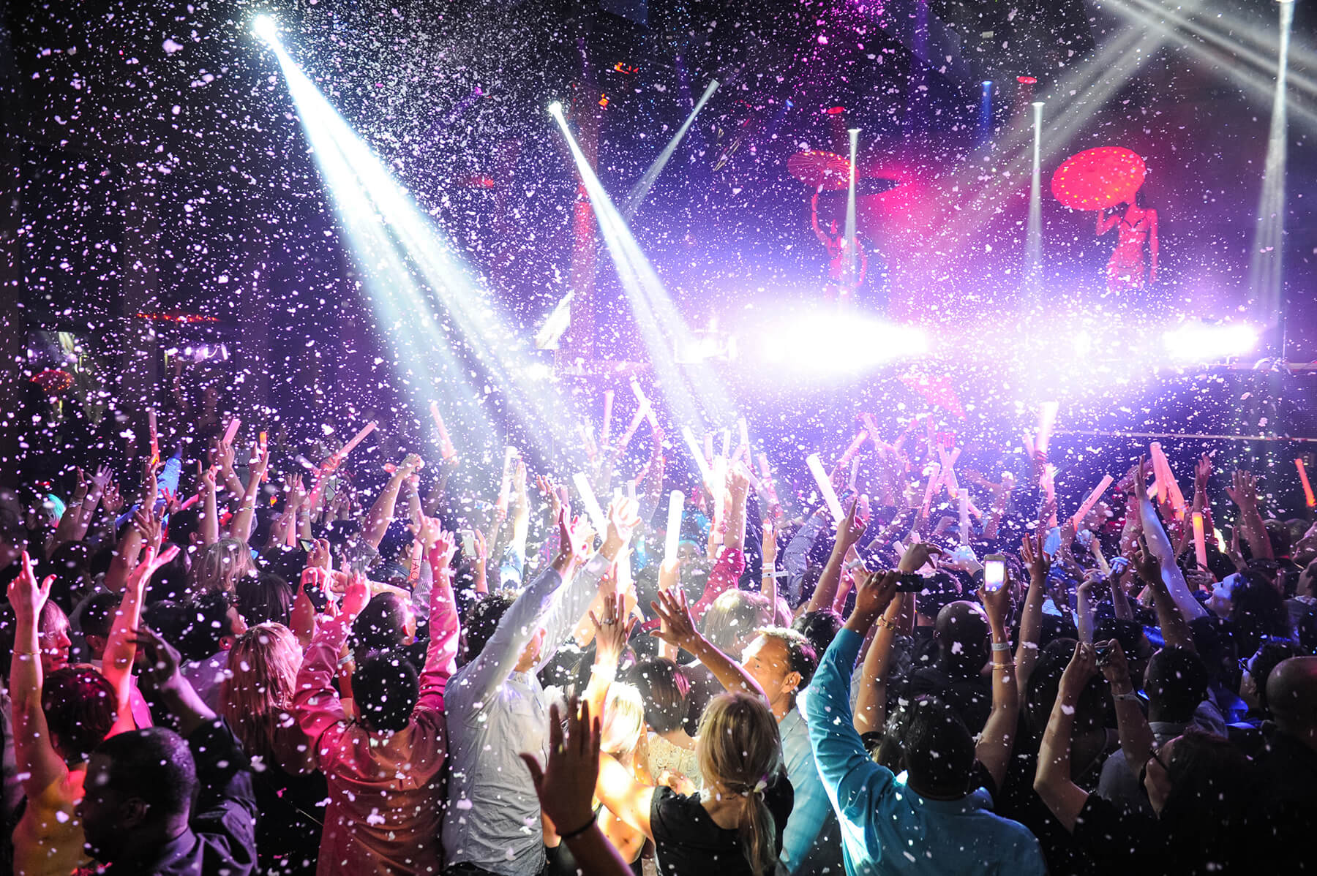

**Bars** – It’s a place where people can drinks especially alcoholic drinks. Normally children’s are not allowed in bar.

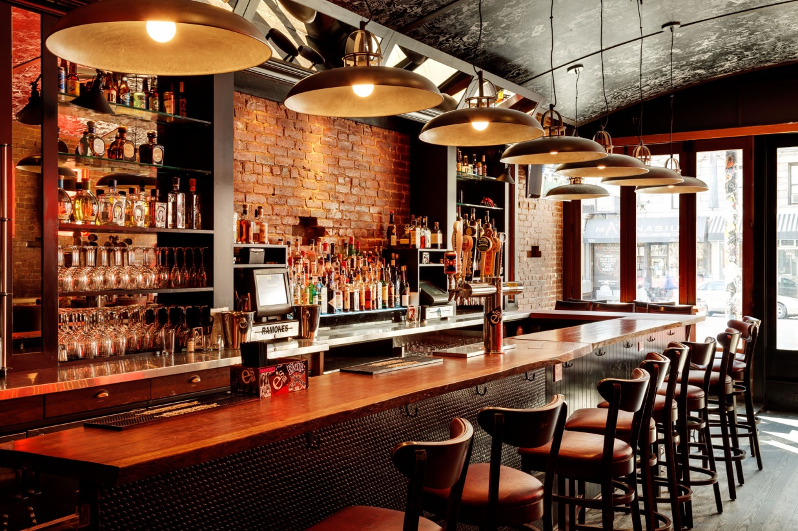

**Conclusion**

Tourism is growing industry in the world. America, Europe, Asia Pacific and Africa growth very high by the tourism. Only in middle east post negative growth. In north and South America is growing very fast.

Tourism is important to the economies of many countries. Tourism creates jobs for local people. It also increases the income of other businesses that supply tourism industry. Tourism is important to the economy of both rich and poor countries. Example tourism in France generated 35 million Euros in 2006 and 2 million jobs. Poorer countries tent to be more dependent on income from tourism than richer ones. For example Europe (45%), Asia and the Pacific (28%), North and south America (19%) and Middle East ( 4%). Tourism is a source of economic development in our country.



**References**

1. <https://www.slideshare.net/SunilKumar148/careers-in-the-hospitality-industry>
2. <https://www.slideshare.net/ChetnaArora10/career-opportunities-in-travel-and-tourism-final>
3. <https://www.slideshare.net/vaishali07/career-in-travel-tourism>
4. <https://www.slideshare.net//FrancisMugogahospitality-management-79489305?qid=fb1c5a3a-b7c4-4078-8fbb-f3a53ed0f542&v=&b=&from_search=2>
5. <https://www.slideshare.net/magielsr/t1-tourism-system-presentation-948850?qid=c7f0efb6-4719-48a9-9365-4ecb2271651b&v=&b=&from_search=6>
6. <https://www.slideshare.net/RahulKaurav/concept-of-tourism-tourism-system-38391715>
7. https://www.slideshare.net/Poddar25/got-3-module
8. <https://www.google.com.sg/search?q=types+of+entertainment+in+tourism&dc>
9. Unknown Author,Unknown date,Online Source, File:Marina Scrub Island Resort, Spa & Marina.JPG,<https://commons.wikimedia.org/wiki/File:Marina_Scrub_Island_Resort,_Spa_%26_Marina.JPG>

**THE END**